**Housing:**

* How do the increase in house prices affect affordable house prices
  + How did covid ect health outcomes interest rates including home/land prices and rent increasing
    - Gov subsidies is not as effective against the higher prices
  + How are these things impacting the different types of affordable housing
  + Home prices increase in turn increase rent crisis bc pushed out of home buying as rent increases impacts ppl who are dependent on affordable housing subsidies or
    - What to do to combat – like increasing gov subs or increasing pov line
* What we want the model to do ex:
  + Model predicts rental prices have a 70% correlation with the increase of need for housing assistance

**Beer/breweries:**

* Can get the beer and connect the average price
  + Loop through api through a certain time
  + See how many beers they had on had for each type
  + National beer sales from small and independent craft breweries
  + Opentap is free
* Gas buddy has an api you can prob look at or can look at gas prices effects bc of inflation and interest rate

Potential Data Sources, notes:

**Breweries:**

* <https://www.kaggle.com/datasets/nickhould/craft-cans>
  + Craft beer dataset for 500+ breweries in the us

**Online learning changes due to pandemic:**

* <https://www.kaggle.com/code/saurav9786/covid-impact-on-digital-learning/notebook>
  + Covid impact on digital learning
  + Datasets not labeled well
    - Hard to figure out what the graphs actually mean beyond percentage displays
    - Part of challenge with better labeled data and goals
* Online education system review
  + <https://www.kaggle.com/datasets/sujaradha/online-education-system-review>
* Us parents Division of labor in pandemic
  + <https://www.openicpsr.org/openicpsr/project/166961/version/V2/view;jsessionid=E3B8DDAFF0991ED4D4A44B49716FDEDA?path=/openicpsr/166961/fcr:versions/V2/SPDLC-Wave-1-Data.dta&type=file>

**Rental Assistance:**

* Project design examples
  + <https://www.cbpp.org/research/housing/federal-rental-assistance-fact-sheets#TN>
  + <https://www.cbpp.org/research/housing/federal-rental-assistance-provides-affordable-homes-for-vulnerable-people-in-all>
* National and State housing facts
  + <https://www.cbpp.org/research/housing/national-and-state-housing-fact-sheets-data>
    - Can be edited to show by state
    - Still cannot find original data sources used to build figures and interactive charts
* Multifamily assistance and section 8 database excel files
  + <https://www.hud.gov/program_offices/housing/mfh/exp/mfhdiscl>
  + 25k rows in both
  + Has info about assisted living
  + Info an mamgement orgs, can be org by state, has addresses for mapping, for profit vs non-profit
    - But a lot of the info in it is contact info
  + Mf_assistance_&_sec8_contracts.xlsx
    - **Has info about the rent to fair market rent(FMR) ratio and % difference**
    - **Only ~5200 are below 80% FMR out of ~24000 data points with results for that section**
    - Has additional details about FMR for 1-4 bed rooms
    - Info on different program types like sec 8 vs section 202(elderly housing assistance)
  + Fair market rents
    - <https://hudgis-hud.opendata.arcgis.com/datasets/HUD::fair-market-rents/about>
    - 36k records – used to det payment standard amounts for the housing choice voucher program
    - 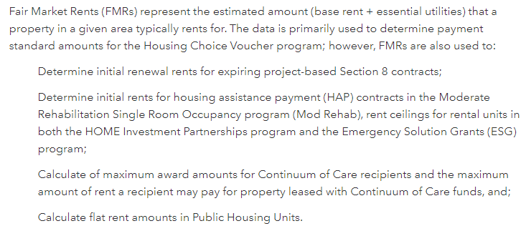
* Has info on rent per person, their incomes, % household elderly, by race, by # bedrooms. Poverty, month waiting(for available housing??) states
  + <https://www.datalumos.org/datalumos/project/100906/version/V1/view?path=/datalumos/100906/fcr:versions/V1/COUNTY_2016.xlsx&type=file>
  + Latest info is for 2016

Housing backup or background info:

* <https://hudgis-hud.opendata.arcgis.com/datasets/HUD::fair-housing-initiatives-program-grantees/explore?location=36.992158%2C-96.633506%2C4.88>
  + Denotes the locations and pertinant information for Fair Housing Initiatives Program (FHIP) grantees.
  + Only useful for mapping info from what I can tell
* Monthly rent affordable for low income household
  + <https://www.statista.com/statistics/1064468/average-rent-affordable-for-low-income-households-usa/>
  + Gonna have to pay for the full xlxs download
* <https://www.huduser.gov/portal/datasets/hads/hads.html>
* Best project description will all needed basic knowledge of subsidized programs:
  + https://www.datalumos.org/datalumos/project/100906/version/V1/view;jsessionid=B76D191DD6C6761D1933F311B8D231FC